**GRBL 5 axis Controller**

**Features**

1. Compatible with most GRBL control board.
2. Compatible serial port chips:CH340/CP210x/PL2303/virtual serial port CDC.
3. Support Uart-115200bps / USB connect.
4. Support Z-probe,reset,Home,Zero function.
5. Support Synchronous mode.
6. 1.8inch LCD
7. Support XYZAB axis.
8. Language:EN/CN

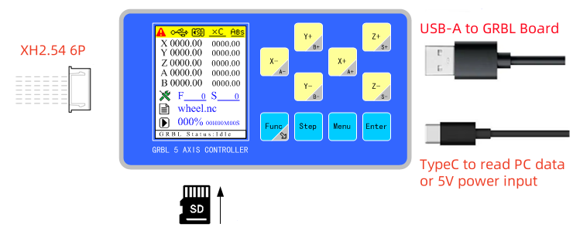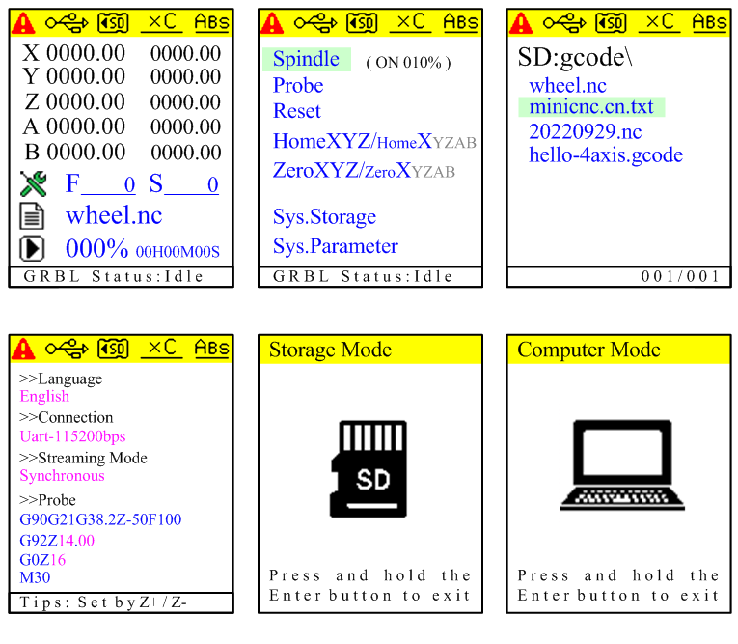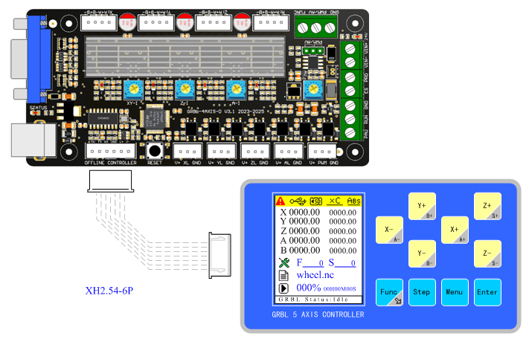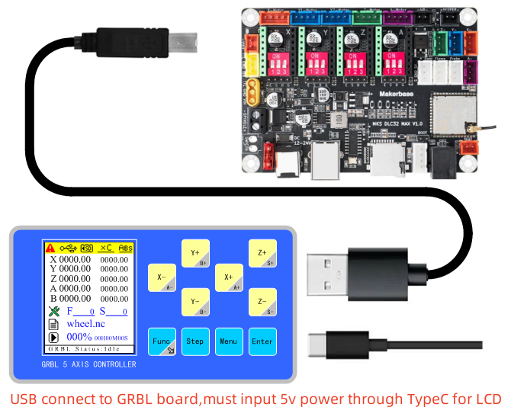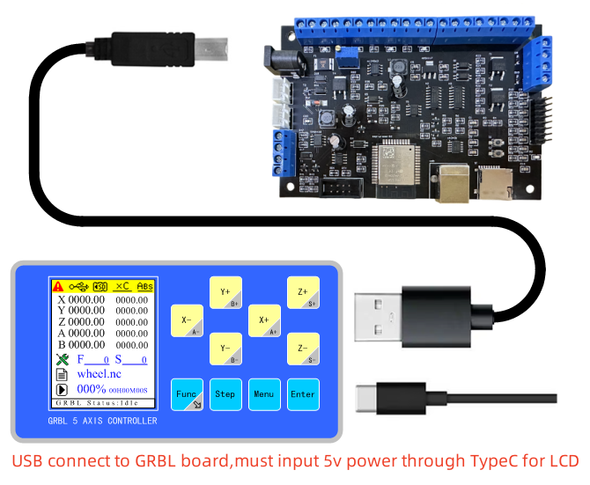

**Interface Introduction**

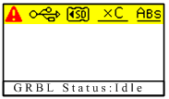

: unconnect or error

: USB connect. Color black-connected,red-failure connect.

: Color black-SD card working,red-SD card error.Support 1g-4g FAT format SD card.

: Press STEP button to adjust distance.

XC-connected, X0.1-0.1mm,X1/X10/X100-1/10/100mm

: Press FUNC to switch Xyz and Abs. Xyz +-,Abs +-. S is to adjust spindle speed.

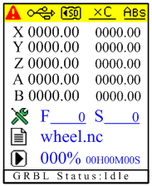

XYZAB is real time coordinates.Left data is Processing coordinates,right is mechanical coordinates.

F is real time feedrate, S is spindle speed.

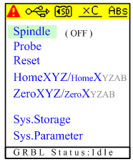

Spindle: ON/OFF

Probe: Z axis calibration

Reset: re-set

Home: original point of XYZ-XYZ axis.

: Switch to any one axis origin.

Zero: XYZ-XYZ axis zero.

: Switch to any one axis zero.

Sys Storage: Save mode

Sys Parameter: set parameter.

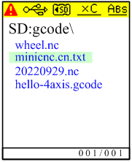

——Save in gcode folder of root directory of SD card.

——Free Gcode file name suffixes.

Press MENU to select,hold MENU to return.ENTER to confirm file then return.

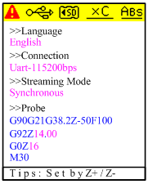

Language: EN/CN switch

Connection: Connection mode.

Uart-115200bps:Serial port connect.

USB-host/CH340:USB connect.

Streaming Mode:Synchronous/Buffered.

Press MENU to switch,Z± to adjust parameters,Press ENTER to save and return.

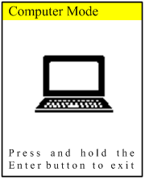

PC mode: LCD will work in PC mode when control on computer,press and hold ENTER to exit PC mode.